Lab Task 03

Rabisa Ali

25K-0876

Task 1: GitHub Profile Setup Create a GitHub account (if you don’t already have one) and update your profile by adding your full name, a short bio, and a professional profile picture.

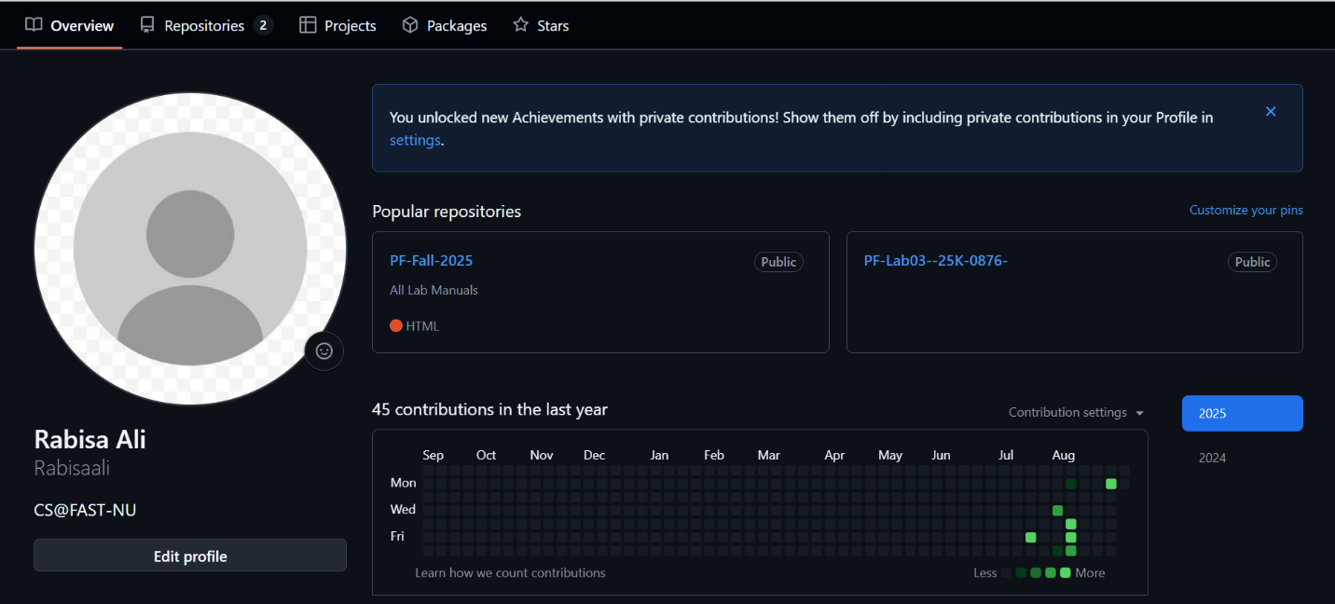

Task 2: First Repository Create a new repository named PF-Lab03-[YourRollNumber]. Add a README.md file describing yourself and your programming interests

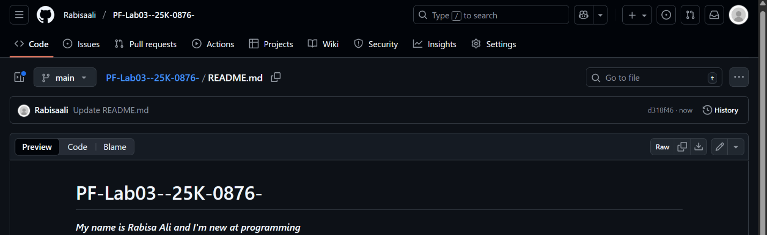

Task 3: Branch and Commit Create a new branch in your repository named lab03-branch. Inside it, create a file named aboutme.md containing your name, degree program, and one hobby. Commit the file

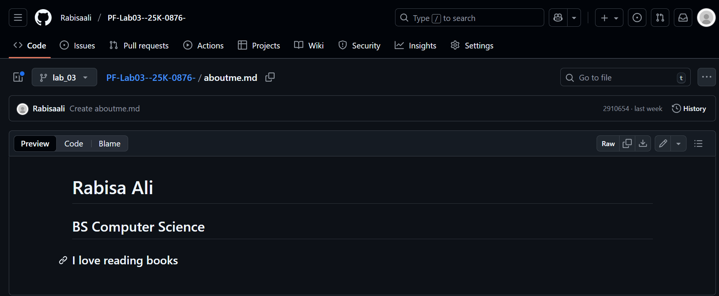

Task 4: Pull Request and Merge Raise a pull request to merge your lab03-branch into the main branch. Successfully merge and delete the branch after merging.

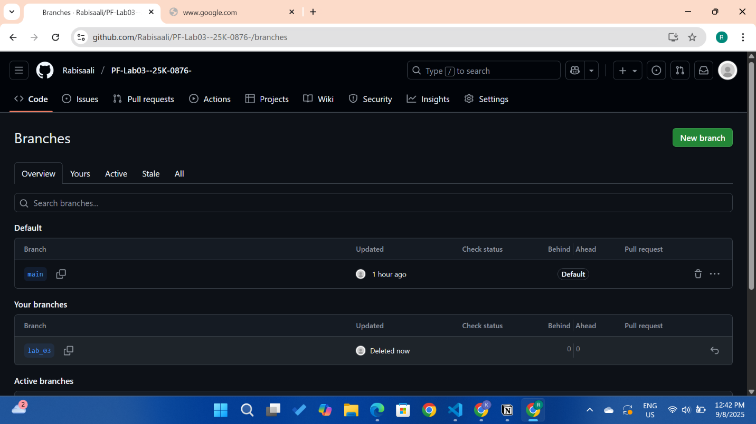

Task 5: Markdown Formatting Edit your README.md to include at least: ● One heading ● One ordered list ● One unordered list ● One bold + italic statement Commit the changes

